**Pizza Sales SQL Queries**

1. KPI’S
2. Total Revenue:





1. Average Order Value:





1. Total Pizza Sold



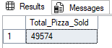

1. Total Order



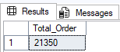

1. Average Pizza Per Order



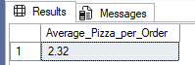

1. Chart Required
2. Daily and Hourly Trend

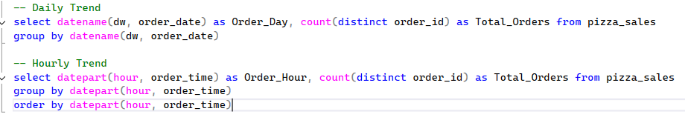 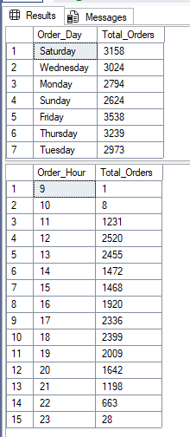

1. Total and Percentage of Sales by Pizza Category



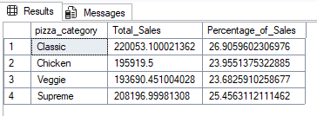

1. Percentage of Sales by Pizza Size



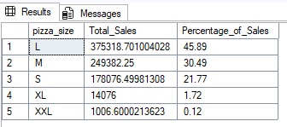

1. Total_pizza_sold

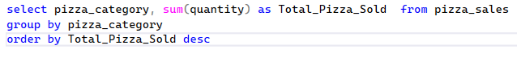

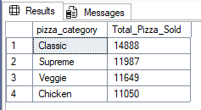

1. Top 5 best pizza sellers by total pizza sold

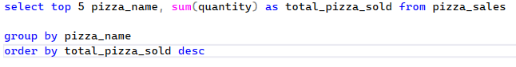

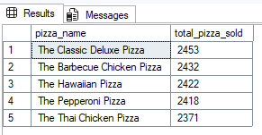

1. Top 5 Worst sellers by total pizza sold

